ABINGDON

MUSIC FESTIVAL

2025 Syllabus

Friday 10th to Sunday 12th October 2025

Abingdon School
Park Road, Abingdon OX14 1DE

Entries close 20th September

Concert: Sunday 2nd November
Trinity Church, Abingdon OX14 1DB

Sponsored by Vineyard Accountants

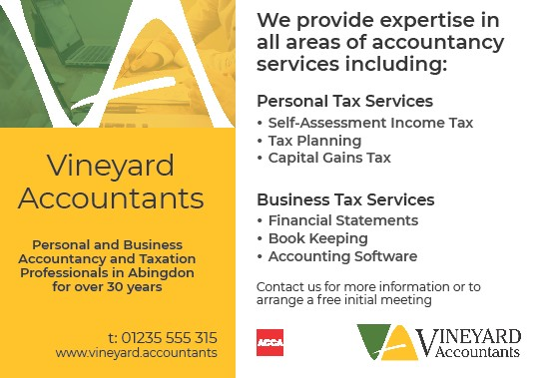

Abingdon Music Festival Association
“A festival with a difference – not a competition but a workshop”

The Abingdon Music Festival Association is proud to present the syllabus for its twenty-fourth Festival. We regularly receive comments that this is a really friendly and informative festival; to those of you who may be new to it, its “difference” means that after every performance, in whatever category, an adjudicator of the highest calibre will give instant comments and helpful advice. Audiences appreciate hearing these assessments immediately instead of having to wait until the end of the class, and performers really enjoy the chance to work on their pieces with an experienced adjudicator. The only element of competition is that each adjudicator is invited to recommend items for selection for the final Sunday evening concert.

The Festival will run from the evening of Friday 10th to Sunday 12th October.
The venue will again be Abingdon School, Park Road, OX14 1DE

The final Concert will be held on Sunday 2 November in
Trinity Church, Conduit Road, Abingdon OX14 1DB

Instructions for entry and Rules may be found on pages 21-22.
Have you considered becoming a Friend of the Festival? See page 11.

Committee
Chairman & Safeguarding Christopher Fletcher-Campbell
Treasurer Sarah Escritt
Festival Secretary Suma Setty
Concerto Secretary Rosemary Joseph
Friends’ Secretary Despina Nikolakis
Members: Diana Hinds, Olga Meadows, Costas
Nikolakis, Malcolm Pearce, Angie Tse

Email: abmusfest@gmail.com

The Festival is a member of the British and International Federation of Festivals for Music, Drama & Speech.

Abingdon Music Festival is very grateful for donations from
Janine Aron in loving memory of Cecil Louis Aron, Wendy Carlin,
the Hart Foundation, the estate of Elizabeth Handscomb (former Chair) and
Sponsorship from Vineyard Accountants

Abingdon Music Festival Association, Registered Charity no. 1072473
ADJUDICATORS

Timothy Barratt (Piano) studied Piano and Viola on a Scholarship at the
Royal Academy of Music, winning many major awards, and completed his studies with Vlado Perlemuter in Paris and Geoffrey Parsons. A performing career throughout the UK and abroad career as soloist, accompanist and chamber music player has spanned more than 30 years, with a particular focus on voice and piano partnership.
Teaching forms a major part of his musical life and he enjoys working with pupils of all ages and levels from beginner to post-graduate. He was Head of Keyboard at Dulwich College for many years whilst also teaching at the RAM and TCM and now pursues a busy freelance
practice.
Formerly a member of the examining, training and review panel for the ABRSM, he now acts as a Syllabus Consultant. He regularly directs Masterclasses and Residential Courses for performers and teachers and is in demand as a Competition and Festival adjudicator.

Jill Morton (Piano) is a distinguished pianist and educator, excelling as a soloist, chamber musician, and teacher. She is a Principal Tutor for the Piano Teachers’ Course UK, the leading professional course for piano pedagogy in Britain. Jill has a popular YouTube channel featuring repertoire from the ABRSM and Trinity graded music syllabuses, as well as other piano repertoire. She regularly delivers masterclasses at universities and specialist music schools across Britain and is a sought-after competition adjudicator. Additionally, Jill teaches at the Perse School in Cambridge and is the founder of Encore! Concerts for All, Big and Small, a series designed to introduce preschool children and their carers to the excitement of live music.

Jane Salmon (Strings) is especially well known as a chamber musician. Her work has taken herto more than 45 countries across the world and has involved her in more than 60 CD
recordings, numerous broadcasts, first performances, festivals, and concerts in many major
venues.
Jane was cellist of the Schubert Ensemble, winner of the Royal Philharmonic prize for chambermusic and a leading exponent of music for piano and strings for 35 years. The group
commissioned over 35 new chamber works, made many recordings and broadcasts and
appeared at major European venues including Wigmore Hall in London and the
Concertgebouw , Amsterdam. 2018 saw the group's celebratory final season with over 50
concerts including two return tours to the USA. A library of live performances are now
available on the Schubert Ensemble's YouTube channel.
A member of the National Youth Orchestra, Jane read music at Clare College Cambridge and
studied cello with Amaryllis Fleming and Johannes Goritzki, attending masterclasses with
Pierre Fournier. She was awarded a number of scholarships and awards and selected by YCAT with recitals at the Wigmore and Purcell Room, a solo tour of India and was on stage solocellist in the National Theatre production of Arthur Millers 'Broken Glass.'
A founder member of Endymion, an ensemble which championed new music as well as
classical repertoire, she has performed many first performances and several times at the BBC
proms. Jane also has been guest principal with the Scottish and English Chamber Orchestras
and London Sinfonietta and played with the Academy of St Martins and Chamber Orchestra ofEurope, and regularly with Longborough Festival Opera and Oxford Philharmonic. She has
given many masterclasses and workshops, adjudicates and examines, and is a tutor in cello and chamber music at the Royal Birmingham Conservatoire.

George Caird (Wind) studied the oboe with Janet Craxton and Evelyn Barbirolli at the Royal Academy of Music,with Helmut Winschermann at the Nordwestdeutsche Musikakademie, and privately with Neil Black. He gained an MA in music at Peterhouse, Cambridge, graduating to pursue a freelance career as an oboist. He worked with many of London’s major orchestras including the London Philharmonic, BBC Symphony, City of London Sinfonia and was a member of The Academy of St. Martin-in-the-Fields from 1983 to 1993. George has also been a member of a number of ensembles, notably as a
founder-member of The Albion Ensemble, Vega Wind Quintet and Caird Oboe Quartet.
In addition to many orchestral recordings, he has recorded CDs of solo and chamber music repertoire including ‘An English Renaissance’ of quintets and quartets for oboe and strings, and Britten’s Six Metamorphoses after Ovid as part of his published study on that work. Among the works written for him are Paul Patterson’s Duologue, John Gardner’s Second Oboe Sonata, Andrew Downes’ sonata, Inthe Gardens of Burdwan, John Mayer’s Abhut Sangit, Gregory Rose’s Oboe Concerto and in chamber music, Elizabeth Maconchy&#39;s Wind Quintet, Paul Patterson&#39;s Comedy for Winds and Jim Parker&#39;s
Mississippi Five.
George joined the Royal Academy of Music as professor of oboe in 1984, became Head of Woodwind in 1987 and Head of Orchestral Studies in 1989. In September 1993, he was appointed Principal of Royal Birmingham Conservatoire, Birmingham City University, a post that he held until August 2010. From 2011 - 2016, George was Artistic Director of the Classical Music Academy, Codarts Rotterdam, from 2017 - 2018, Interim Principal of the Royal Welsh College of Music and Drama and from 2020 – 2021, Interim Principal of the Royal Central School of Speech and Drama. George continues to teach the oboe at Royal Birmingham Conservatoire, is President of the Barbirolli International Oboe Competition, President of the Bromsgrove International Music Competition and a Trustee of the Countess of Munster Musical Trust. In January 2024, George was elected Chair of the
Royal Society of Musicians.

Christine Cairns (Voice) has sung in concerts all over the world. Some of her highlights include concerts with the Vienna the Berlin Philharmonic the Los Angeles philharmonic orchestras with conductors such as Andre Previn Sir Simon Rattle and her husband John Lubbock.
When their younger son was diagnosed with severe autism she decided to devote her professional life to teaching since when she has taught in the conservatoire in Birmingham The Guildhall school of music and Drama and privately in Oxfordshire. She has also examined for several of the London colleges adjudicated at many competitions and given master classes with a wide range of students.
Christine is delighted to be back at the Abingdon festival this year - a festival she particularly enjoys.

How you can help secure the future of our much-valued festival

FRIENDS OF ABINGDON MUSIC FESTIVAL SUBSCRIPTION SCHEME

If you are likely to attend more than one session during the Festival, have several performers in your family or would simply like to keep entry fees low by offering financial support, then become a Friend.

All friends are entitled to:
- A personal copy of the Festival Syllabus and free programme and admission to all sessions during the Festival
- Free ticket for the Festival showcase concert
- Advanced notification of and free admission to extra events such as the Concerto Competition, and notification of prize winners’ concerts
- Invitation to attend the AGM
- Discount of 10% off purchases from Blackwells Music Shop.
You are asked to make a minimum donation of £15 (individual) or £20 (family). Your name will be acknowledged in the Festival programme (unless you would prefer it not to be).
Please contact Despina Nikolakis, Friends’ Secretary at despina.nikolakis@gmail.com for further details.

BECOME A CORPORATE DONOR

In the current economic climate, funding for the Festival has become more difficult to secure from our established sources. Therefore we are inviting donations from organisations and businesses who are interested in music and who support the ethos of the Festival and believe it should continue to provide musical opportunities and education in the widest sense for local musicians.
We hope you will consider supporting us. A relatively small amount can make a huge difference to offsetting the operating costs of the Festival. We can offer you:

- Acknowledgement of your support in the Festival syllabus and programme
- An opportunity to advertise in syllabus and programme. Donations of £200+ will secure free advertising opportunities
- Advance notice of all our events – the Festival weekend and Concerto competition
- An invitation to interval receptions to meet local dignitaries and other sponsors
- Free passes to all events during the Festival weekend and Concerto competition
- An opportunity to associate your sponsorship with particular aspects of the Festival which you are particularly interested in – for example, the piano classes

Please visit our website www.abmusfest.org.uk for more information about the Festival.
Registered charity no. 107247

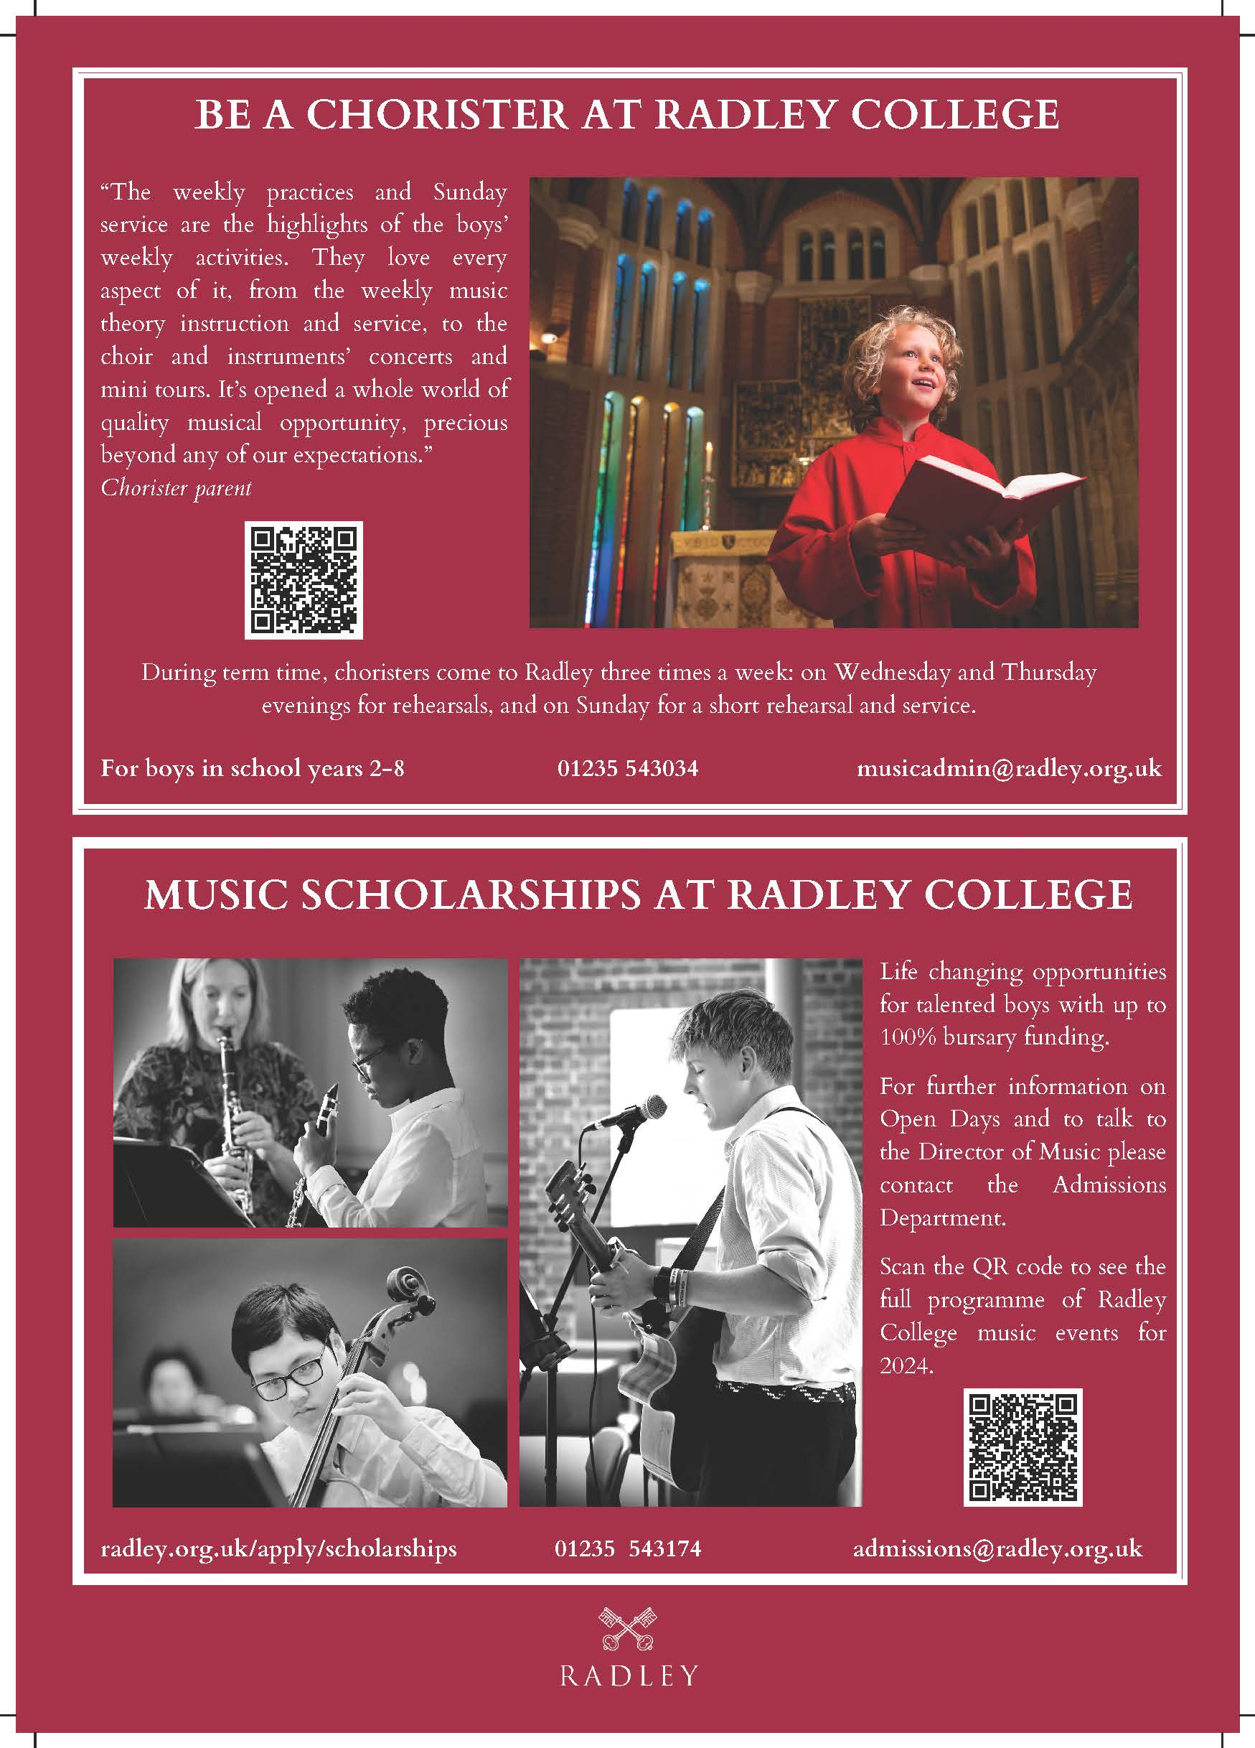

PIANO CLASSES

Solos, own choice of music
For duets, see under ENSEMBLES
It is expected that the majority of performers will enter the class appropriate to their age, but performers of above-average ability may prefer to enter a more advanced class.
For classes P0 to P3, approximate grade of piece will be requested on online entry form.

P0 | Beginners (learning for under 18  months) | Time limit: 2 minutes Fee £5.50
P1 | 8 years & under | Time limit: 2 minutes Fee £5.50
P2 | 10 years & under | Time limit: 3 minutes Fee £7.00
P3 | 12 years & under | Time limit: 3 minutes Fee £7.00
P4 | 14 years & under | Time limit: 4 minutes Fee £7.75
P5 | 16 years & under | Time limit: 4 minutes Fee £8.25
P6 | 18 years & under | Time limit: 6 minutes Fee £8.25
P7 | Adult (non-professional) | Time limit: 10 minutes Fee £9.50
P8 | Open (no age restriction) | Time limit: 10 minutes Fee £9.50
PR1 | Recital, 19 & under, Grades 4-6* | Time limit: 10 minutes Fee £9.50
PR2 | Recital, 19 & under, Grades 7-8* | Time limit: 12 minutes Fee £11.00
PR3 | Recital, Open (post-Grade 8*) | Time limit: 15 minutes Fee £13.00
#Where two pieces are presented, the adjudicator may choose to comment on only one.
*The grades refer to the choice of repertoire, not to the performer's current level of attainment

Make sure your piece is not too long!
Strict closing date for entries – 20th September

STRING CLASSES

Solos, own choice of music
For duos, trios, etc., see under ENSEMBLES
It is expected that the majority of performers will enter the class appropriate to their age, but performers of above-average ability may prefer to enter a more advanced class.
For classes S1 to S3, approximate grade of piece will be requested on online entry form.

S1 | Beginners (learning for under 18 months) | Time limit: 2 minutes# Fee £5.50
S2 | 10 years & under | Time limit: 3 minutes# Fee £7.00
S3 | 12 years & under | Time limit: 3 minutes# Fee £7.00
S4 | 14 years & under | Time limit: 4 minutes Fee £7.75
S5 | 16 years & under | Time limit: 4 minutes Fee £7.75
S6 | 18 years & under | Time limit: 6 minutes Fee £8.25
S7 | Adult (non-professional) | Time limit: 10 minutes Fee £9.50
S8 | Open (no age restriction) | Time limit: 10 minutes Fee £9.50
SR1 | Recital, 19 & under, Grades 4-6* | Time limit: 10 minutes Fee £9.50
SR2 | Recital, 19 & under, Grades 7-8* | Time limit: 12 minutes Fee £11.00
SR3 | Recital, Open (post-Grade 8*) | Time limit: 15 minutes Fee £13.00
#Where two pieces are presented, the adjudicator may choose to comment on only one.
*The grades refer to the choice of repertoire, not to the performer's current level of attainment

Strict closing date for entries – 20th September

Music for official accompanists prepared by 30 September

WOODWIND AND BRASS CLASSES

(including recorder and saxophone)

Solos, own choice of music
For duos, trios, etc., see under ENSEMBLES
It is expected that the majority of performers will enter the class appropriate to their age, but performers of above-average ability may prefer to enter a more advanced class.
For classes W1 to W3, approximate grade of piece will be requested on online entry form.

W1 | Beginners (learning for under 18  months) | Time limit: 2 minutes# Fee £5.50
W2 | 10 years & under | Time limit: 3 minutes# Fee £7.00
W3 | 12 years & under | Time limit: 3 minutes# Fee £7.00
W4 | 14 years & under | Time limit: 4 minutes Fee £7.75
W5 | 16 years & under | Time limit: 4 minutes Fee £7.75
W6 | 18 years & under | Time limit: 6 minutes Fee £8.25
W7 | Adult (non-professional) | Time limit: 10 minutes Fee £9.50
W8 | Open (no age restriction) | Time limit: 10 minutes Fee £9.50
WR1 | Recital, 19 & under, Grades 4-6* | Time limit: 10 minutes Fee £9.50
WR2 | Recital, 19 & under, Grades 7-8* | Time limit: 12 minutes Fee £11.00
WR3 | Recital, Open (post-Grade 8*) | Time limit: 15 minutes Fee £13.00
#Where two pieces are presented, the adjudicator may choose to comment on only one.
*The grades refer to the choice of repertoire, not to the performer's current level of attainment

Make sure your piece is not too long!
Strict closing date for other entries – 20th September
Music for official accompanists prepared by 30 September

VOCAL CLASSES

Solos, own choice of music
For duos, trios, etc., see under ENSEMBLES
It is expected that the majority of performers will enter the class appropriate to their age, but performers of above-average ability may prefer to enter a more advanced class.
For classes V1 to V3, approximate grade of piece will be requested on online entry form.

V1 | Beginners (learning for under 18  months) | Time limit: 2 minutes# Fee £5.50
V2 | 10 years & under | Time limit: 3 minutes# Fee £7.00
V3 | 12 years & under | Time limit: 3 minutes# Fee £7.00
V4 | 14 years & under | Time limit: 4 minutes Fee £7.75
V5 | 16 years & under | Time limit: 4 minutes Fee £7.75
V6 | 18 years & under | Time limit: 6 minutes Fee £8.25
V7 | Adult (non-professional) | Time limit: 10 minutes Fee £9.50
V8 | Open (no age restriction) | Time limit: 10 minutes Fee £9.50
VR1 | Recital, 19 & under, Grades 4-6* | Time limit: 10 minutes Fee £9.50
VR2 | Recital, 19 & under, Grades 7-8* | Time limit: 12 minutes Fee £11.00
VR3 | Recital, Open (post-Grade 8*)  The Janet McMullin Memorial Class | Time limit: 15 minutes  Fee £13.00
#Where two pieces are presented, the adjudicator may choose to comment on only one.
*The grades refer to the choice of repertoire, not to the performer's current level of attainment

VP1 Popular Vocal, 14 years and under Time limit: 4 minutes
Fee £7.75
VP2 Popular Vocal, 18 years and under Time limit: 6 minutes
Fee £8.25
These classes are for rock and modern stage musicals repertoire.

ENSEMBLES

Own choice of music
It is expected that the majority of performers will enter the class appropriate to their age, but performers of above-average ability may prefer to enter a more advanced class.

EPD1 | Piano duo, 10 years & under | Time limit: 3 minutes Fee £7.50
EPD2 | Piano duo, 12 years & under | Time limit: 3 minutes Fee £7.50
EPD3 | Piano duo, 14 years & under | Time limit: 4 minutes Fee £8.00
EPD4 | Piano duo, 18 years & under | Time limit: 6 minutes Fee £9.00
EPD5 | Piano duo, adult (non-professional) | Time limit: 10 minutes Fee £11.00
ES1 | String ensemble, 2-6 players,  any combination, 18 years & under | Time limit: 5 minutes Fee £9.00
ES2 | String ensemble, 2-6 players,  any combination, any age but must be  non-professional | Time limit: 8 minutes Fee £10.00
EW1 | Woodwind and/or brass ensemble, 2-6 players, any combination, 18 years & under | Time limit: 5 minutes Fee £9.00
EW2 | Woodwind and/or brass ensemble, 2-6 players, any combination, any age but must be non-professional | Time limit: 8 minutes Fee £10.00
EC1 | Chamber ensemble including piano,  2-6 players, any combination,  18 years & under | Time limit: 5 minutes Fee £9.00
EC2 | Chamber ensemble including piano,  2-6 players, any combination,  any age but must be non-professional | Time limit: 8 minutes Fee £10.00
Make sure your piece is not too long!

Strict closing date for entries – 20th September

ENSEMBLES (cont.)

EL  EF | Large instrumental ensemble  (7 or more performers, any age,  any combination, non-professional)  Family ensemble, any age,  any combination | Time limit: 8 minutes Fee £12.00  Time limit: 5 minutes  Fee £9.00
EV1 | Vocal ensemble, 2-6 singers,  any combination, 18 years & under | Time limit: 5 minutes Fee £9.00
EV2 | Vocal ensemble, 2-6 singers,  any combination, any age but must be non-professional | Time limit: 8 minutes Fee £10.00
EChC  EChS  EChL | Church Choir – any number & age  Small Choir up to 20 – any age  non-professional  Large Choir over 20 – any age  non-professional | Time limit: 8 minutes  Fee £10.00  Time limit: 8 minutes  Fee £10.00  Time limit: 8 minutes  Fee £12.00
ER1 | Recital, 19 & under, Grades 4-6*,  any vocal or instrumental ensemble,  2-6 performers | Time limit: 10 minutes Fee £10.00
ER2 | Recital, 19 & under, Grades 7-8*,  any vocal or instrumental ensemble,  2-6 performers | Time limit: 12 minutes Fee £12.00
ER3  EM | Recital, Open (post-Grade 8*),  any vocal or instrumental ensemble,  2-6 performers  Any individual or group not already mentioned, in any idiom or style (pop, jazz, handbells, etc.) - any age, non-professional. | Time limit: 15 minutes  Fee £14.00  Time limit: 6 minutes  Fee £8.50
*The grades refer to the choice of repertoire, not to the performers' current level of attainment

COMPOSITION CLASSES

Performance may be live or taped; a copy of the score should be provided if possible
C1 | Original composition, 16 years & under | Time limit: 4 minutes Fee £7.00
C2 | Original composition, 18 years & under | Time limit: 5 minutes Fee £7.50
C3 | Original composition, adult  (non-professional) | Time limit: 8 minutes  Fee £8.50
FESTIVAL CONCERT

Sunday 2nd November
6 pm
Trinity Church, Conduit Road, Abingdon OX14 1DB

DATES to REMEMBER:

Strict closing date for all entries: 20th September
Changes to entry details and music to accompanists by 30th September

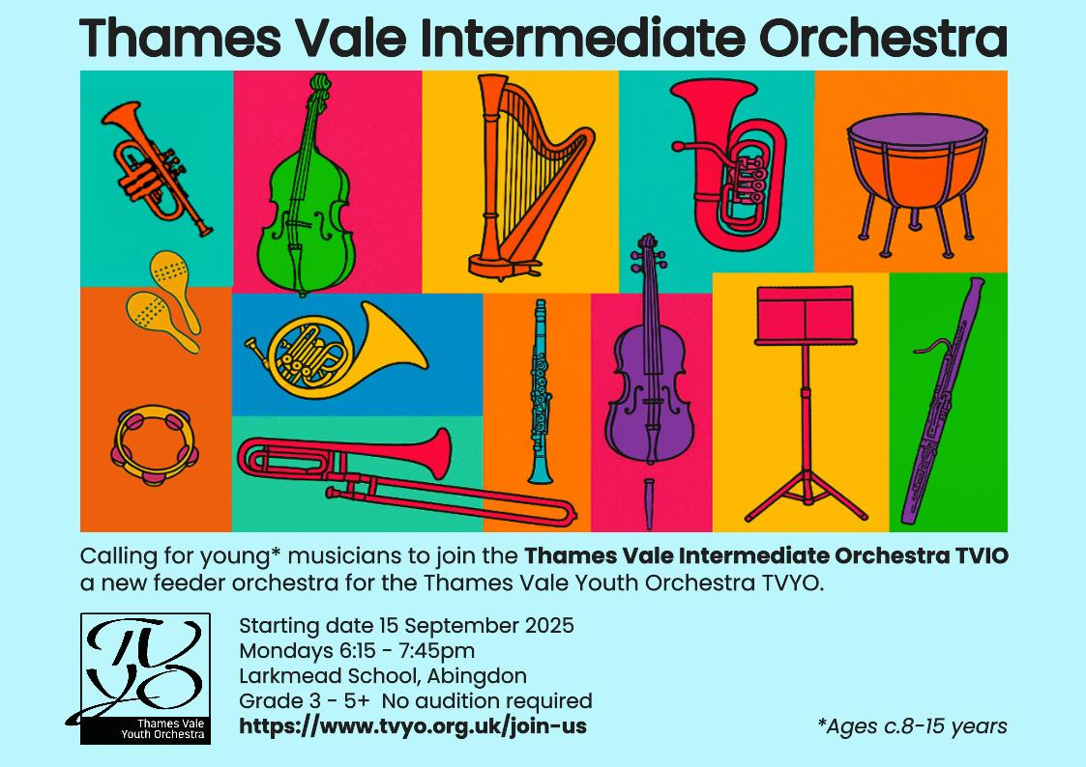

INSTRUCTIONS for ENTRY and FESTIVAL REGULATIONS

ENTRIES should preferably be made using the online entry system via the link
https://amf.runmyfestival.net/runMyFestival/home/orghome.jsf
which is available electronically on the website, or by using the form downloadable from the website: www.abmusfest.org.uk.
All entries must be received by 20 September 2025; late entries will not be accepted. Any changes to entries must be completed by 30 September.
AGE must be reckoned as on 09 October 2025.
FEES must be paid at time of entry, preferably using BACS, or by cheque payable to ‘Abingdon Music Festival Association’. Fee amounts are shown in the schedule of classes. Once an entry has been accepted, no fees will be refunded.
An ACCOMPANIMENT must be provided if the chosen music requires one. Performers may bring their own accompanists, or use one of the Festival’s experienced official accompanists; booking details may be found on next page.
A pre-recorded accompaniment is permissible only when the style of the chosen music demands it.
The TIME LIMIT for each class is stated in the schedule. This limit must not be exceeded; if it is, the performance may be stopped at the end of the prescribed time. As last year, the single-piece limit for classes 1-3 in each Section has been lifted, but adjudicators reserve the right to comment on only one piece where two are presented.
CONDUCT: All performers should arrive at least 10 minutes before the stated time for their class. Any performer not present when called may be disqualified.
Performers should be prepared to announce their piece.
A brief discussion by the adjudicator will be given after each performance.
COPIES: Performers must provide one copy of each piece to be performed for use by the adjudicator during the performance. This may be a photocopy, providing that the performer has the original printed copy available at the time of the performance. No other photocopied music may be used, and adjudicator photocopies must be destroyed immediately after the Festival. Exception may be made for legally downloaded copies of music in the public domain / out of copyright or offered for sale electronically by music publishers or suppliers.
SAFEGUARDING: In accordance with the rules of the British & International Federation of Festivals, the Festival has a Safeguarding policy which requires that all young people under the age of 18 are accompanied by an appropriate adult throughout their time spent at the Festival. The organisers cannot be responsible for this supervision.
DATA PROTECTION ACT: Performers’ details as submitted at entry may be held on computer files for the purposes of Festival management and for sending information about the Festival and associated events only. The information will not be disclosed to any third party.
PHOTOGRAPHY & RECORDING: The use of sound and video recording equipment is prohibited. ‘Still’ photography without flash may be permitted on application to a member of the Festival staff, but only of a single participant at the end of his/her performance by his/her parent/responsible adult.

The Committee reserves the right to alter, modify or cancel any of the arrangements detailed in the syllabus, and its decision in all questions or disputes is final.
FESTIVAL CONTACT for all enquiries: abmusfest@gmail.com

OFFICIAL ACCOMPANISTS
Performers wishing to book the services of one of the official accompanists should indicate this by ticking the relevant box on entry form.

The name of the relevant accompanist will be advised as soon as possible after 20 September. A copy of each piece for accompaniment, with appropriate annotations including metronome marks, must be sent to the assigned accompanist as soon as notification is received.
Please note the regulations regarding the use of photocopies on previous page.
Contact should be made with the assigned accompanist to arrange a rehearsal in good time; accompanists have many commitments outside the Festival and may not be able to accommodate late requests. The fee for rehearsal with accompanist is £40 per hour pro rata. Except for Recital class rehearsals, half-an-hour or less is usually adequate. Rehearsal fees must be paid direct to the accompanist at the rehearsal.
Private arrangements with official accompanists must be completed by 30 September.

HELP WANTED!

During the Festival, we shall need helpers to act as stewards and programme sellers, and to ensure the smooth running of the event. If you can spare some time to help during the Festival (even if only an hour or two) please email abmusfest@gmail.com or telephone 07889 131372.

